**DBMS PROJECT**

**TOPIC: LIBRARY MANAGEMENT**

**NAME: ANVITA AJAY MAHAJAN**

**DIVISION: 1**

**MIS: 112003080**

**BATCH: T5**

OUTPUT SCREENSHOTS:

REGISTRATION PAGE:

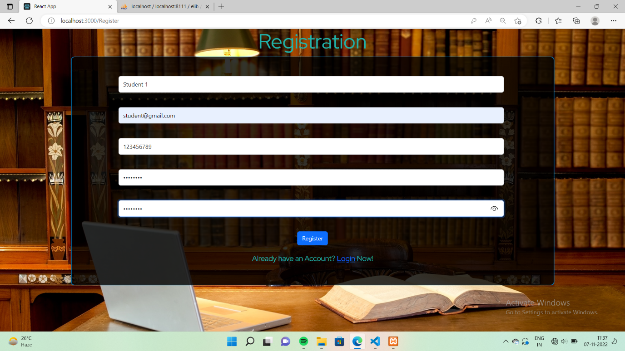

REGISTRATION TABLE DISPLAYING ALL THE BOOKS THAT ARE LOST:

:

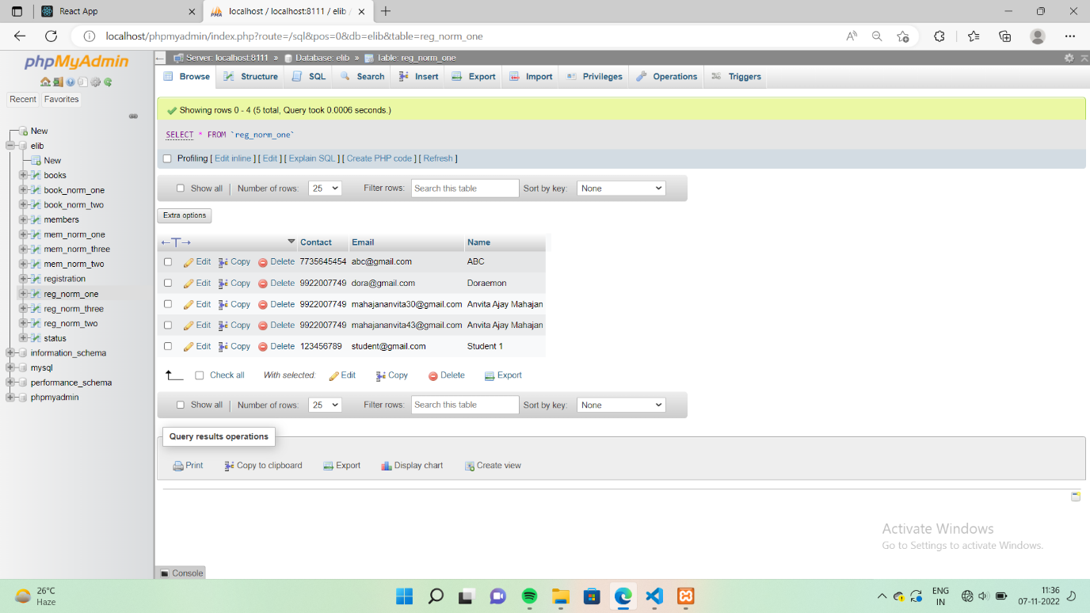

LOGIN PAGE:

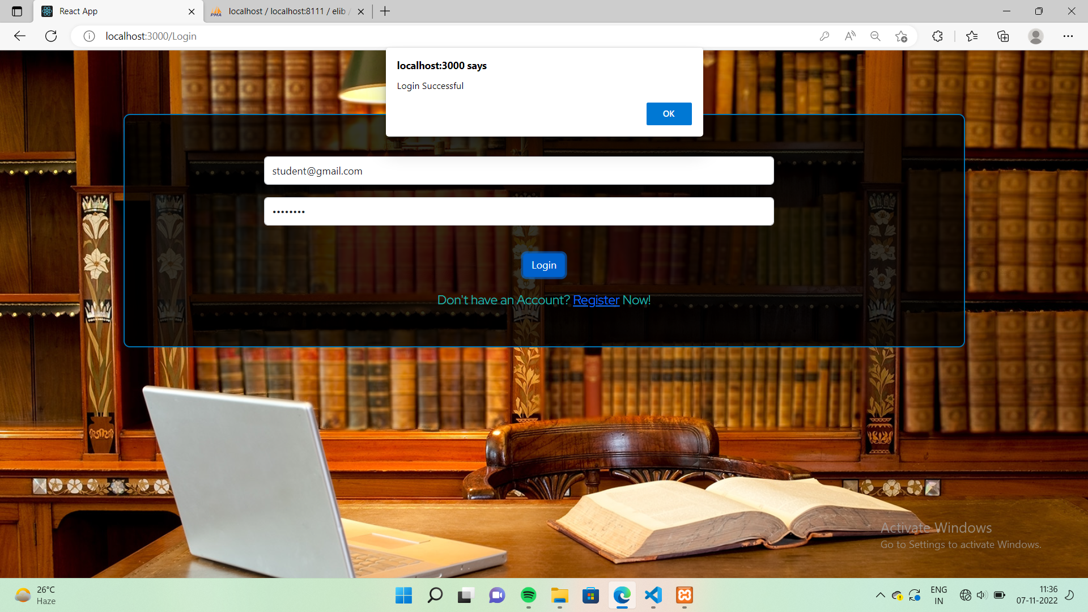

MAINPAGE:

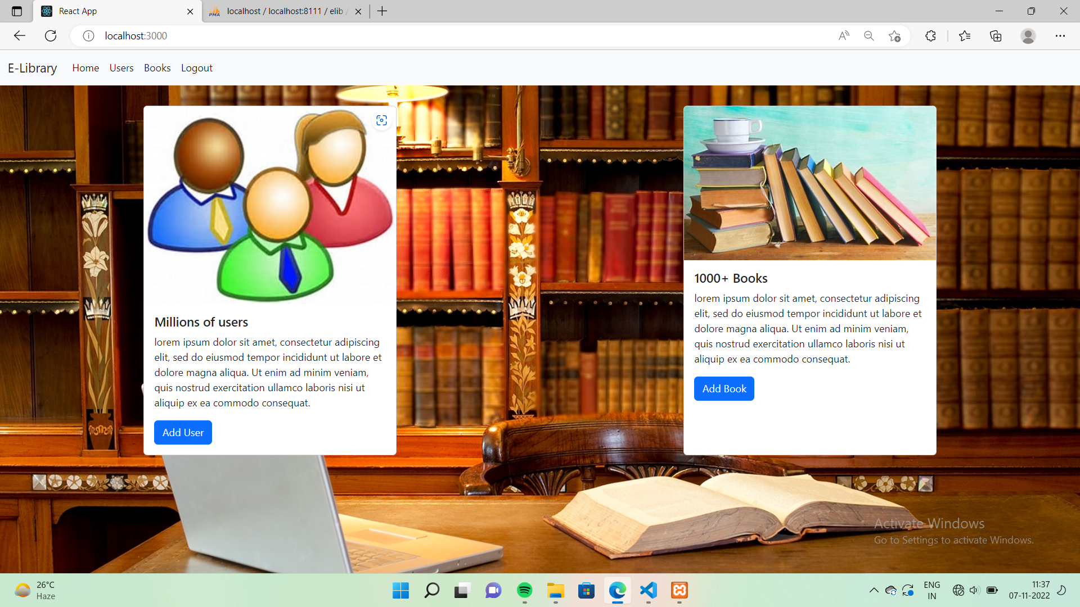

ADD NEW MEMBER:

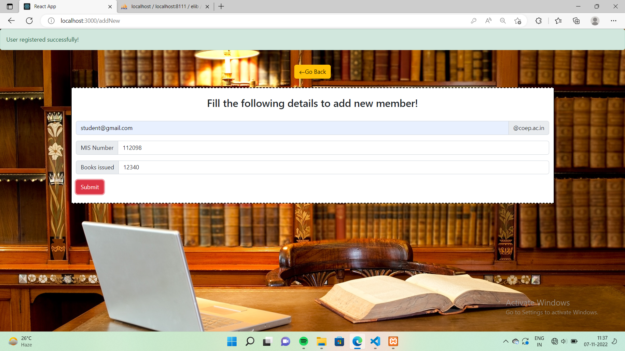

MEMBER DATABASE:

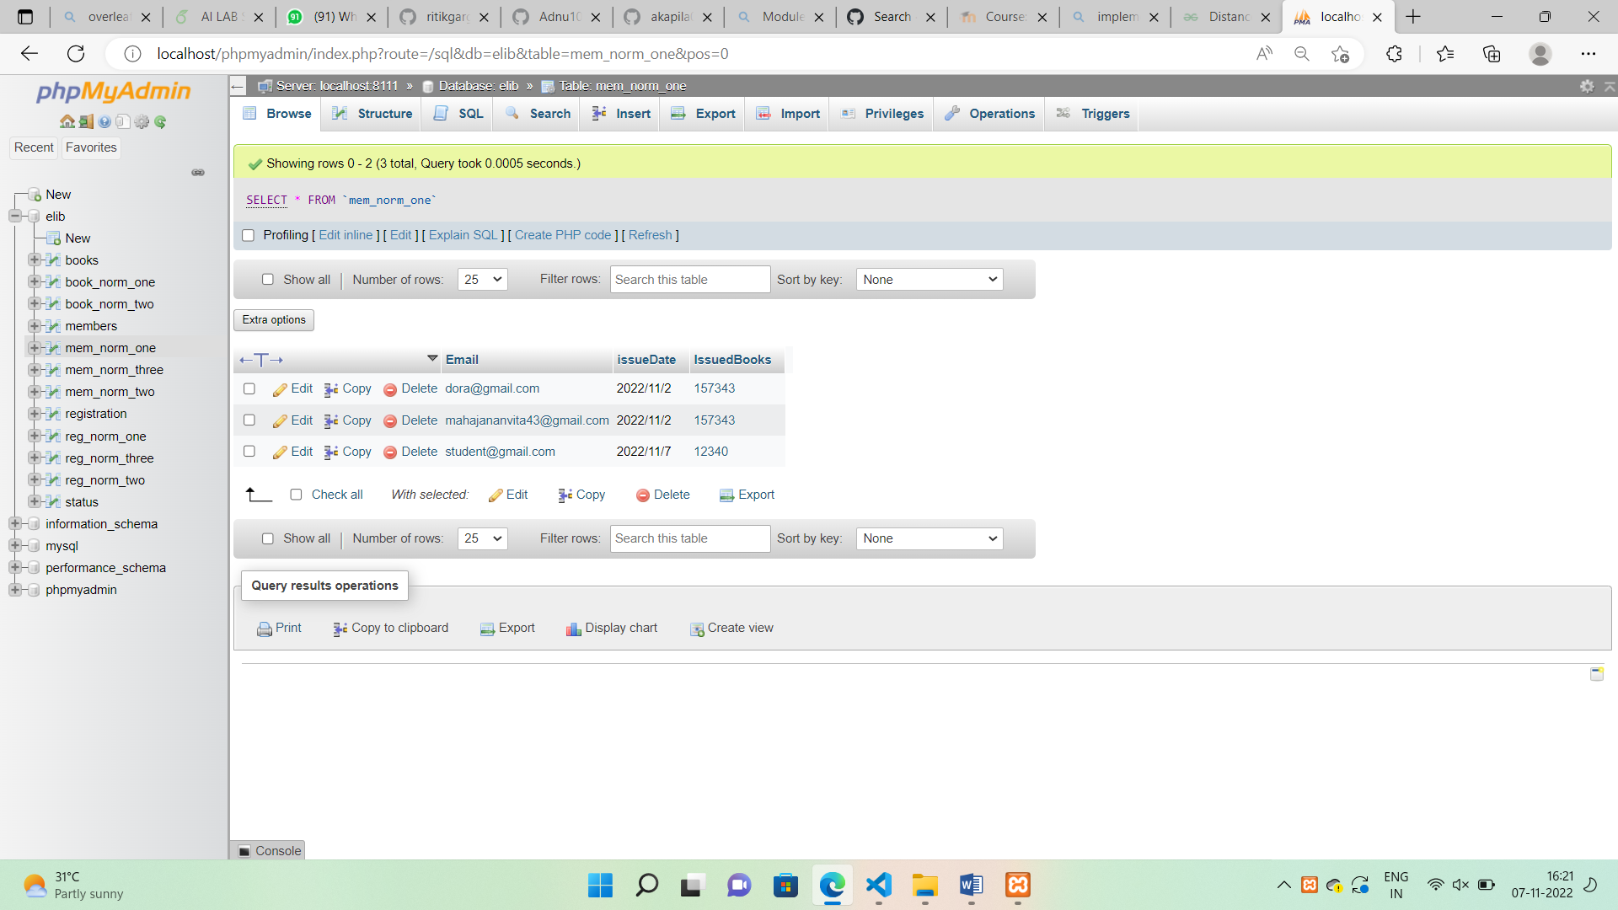

DISPLAYING ALL THE MEMBERS WHO HAVE ISSUED A BOOK:

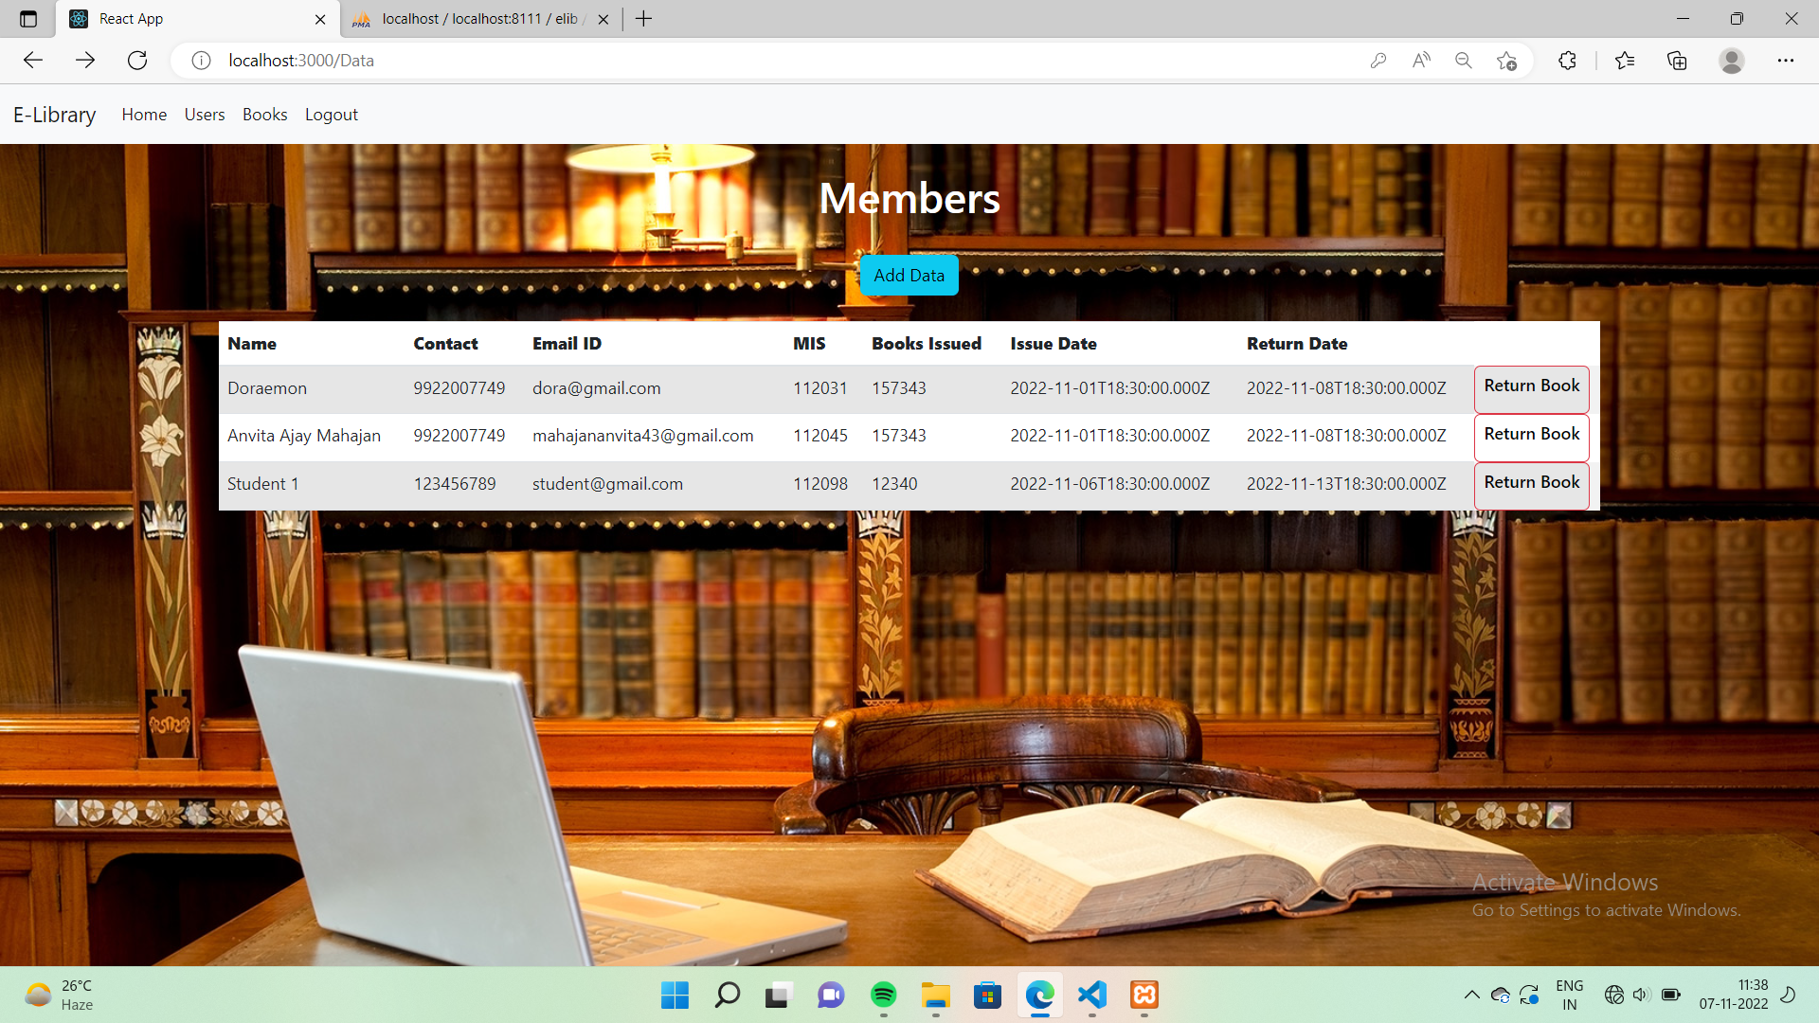

ALL BOOKS:

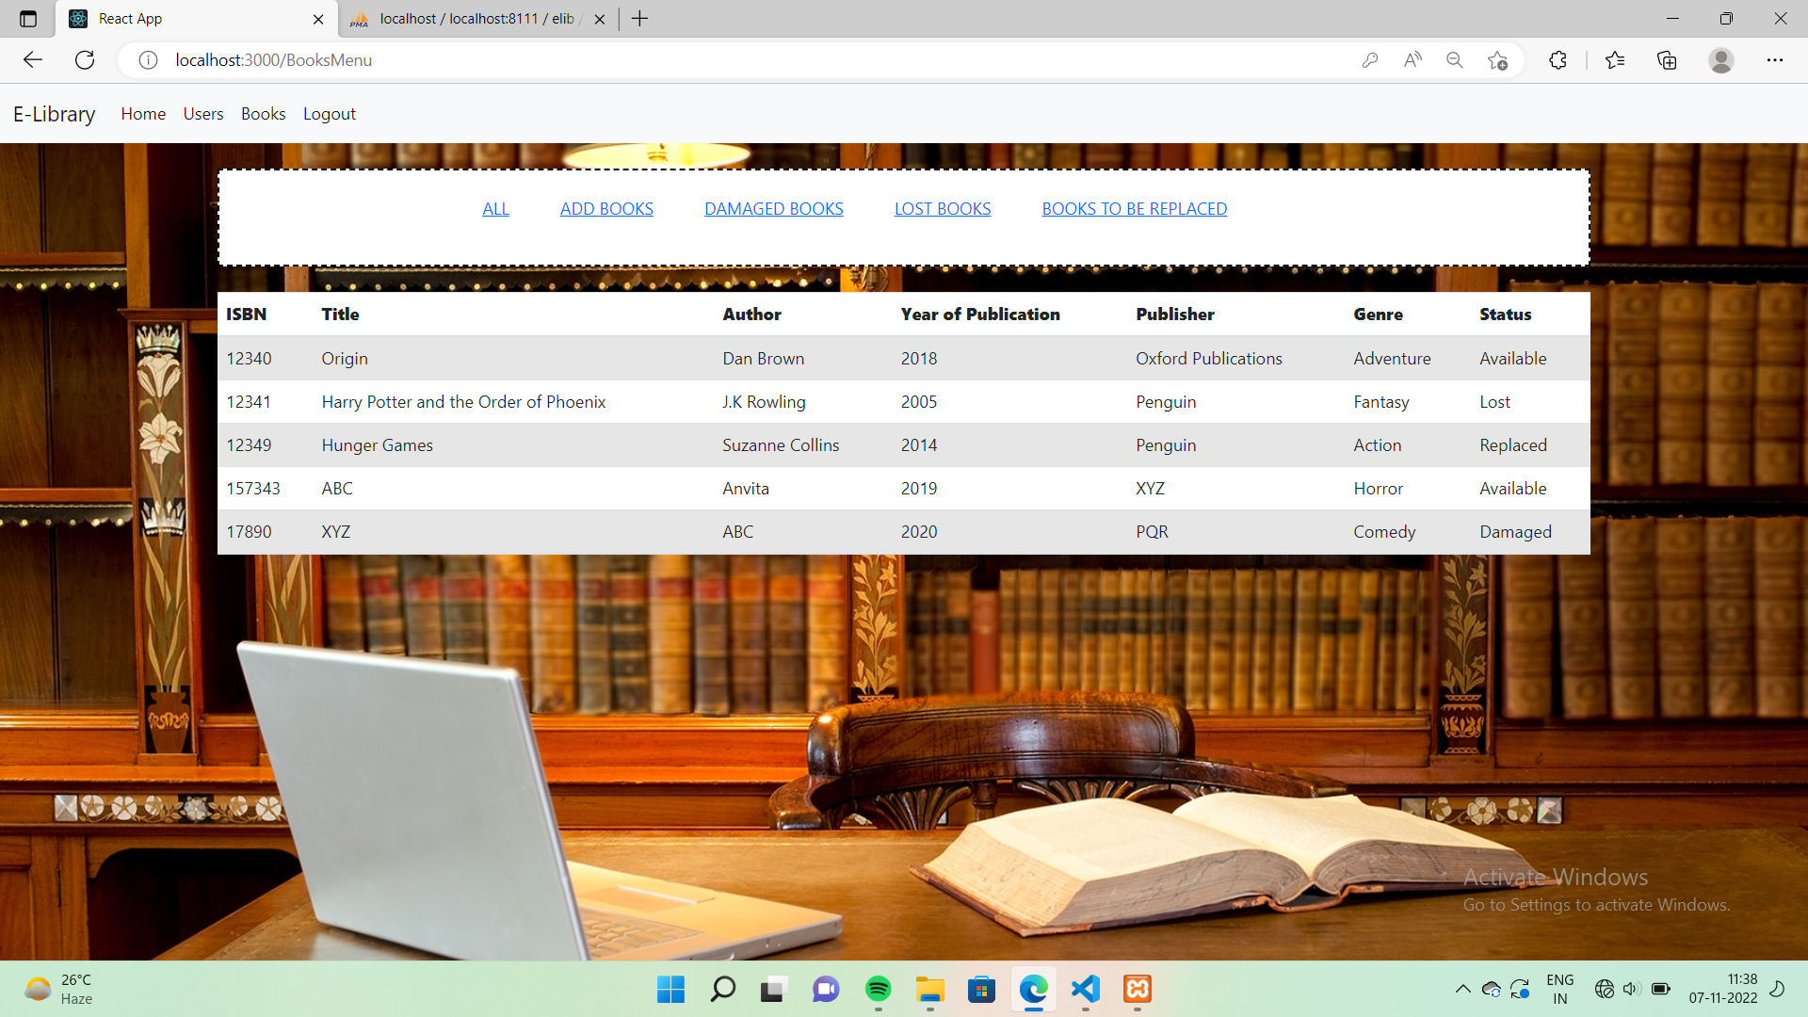

FORM FOR ADDING NEW BOOK:

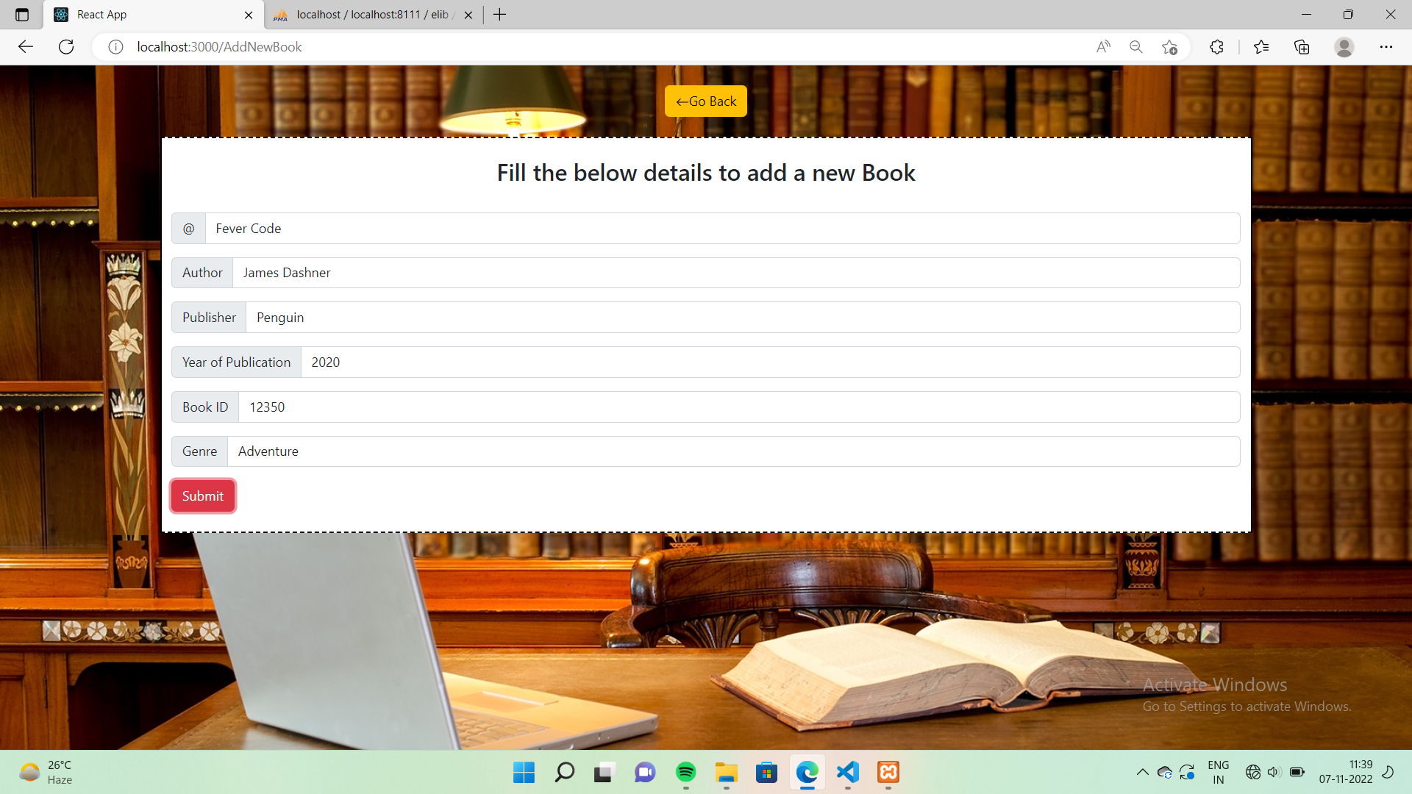

BOOKS DATABASE:

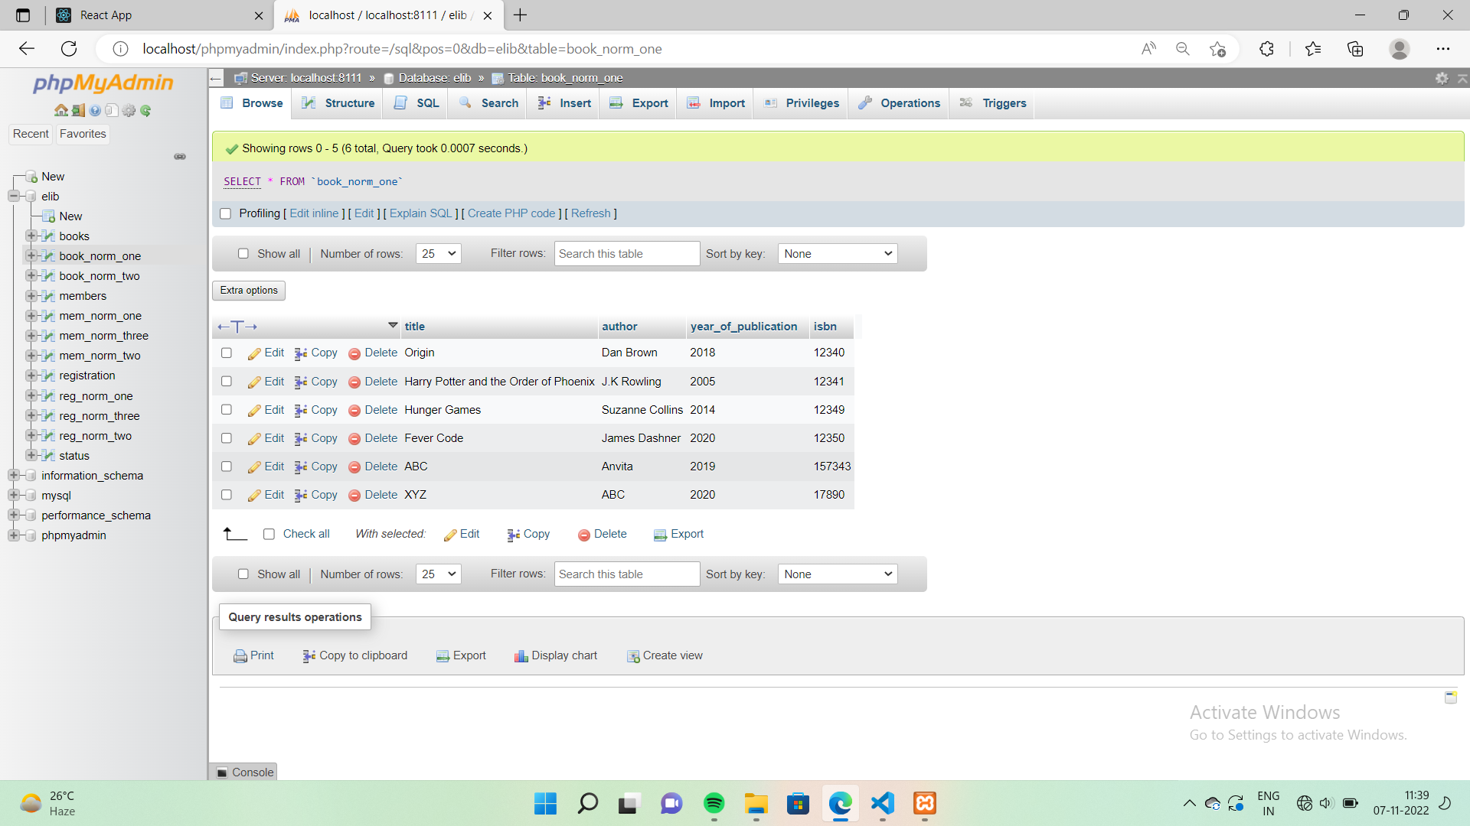

DISPLAYING ALL THE BOOKS AVAILABLE:

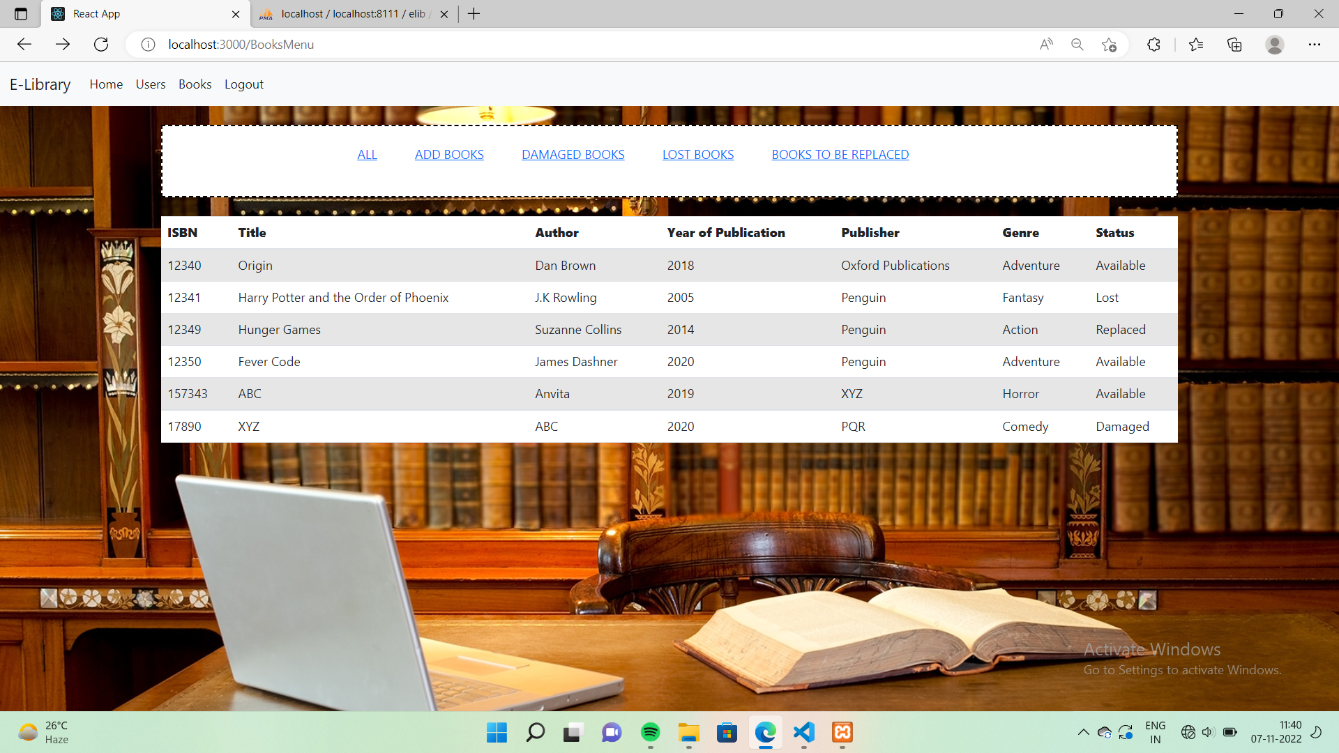

DISPLAYING ALL THE BOOKS TO BE REPLACED:

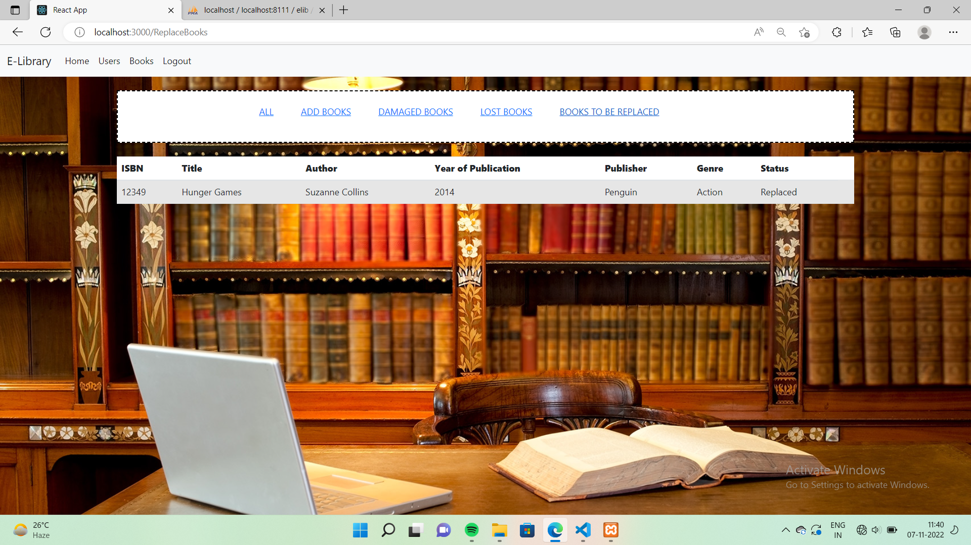

DISPLAYING ALL THE BOOKS THAT ARE LOST:

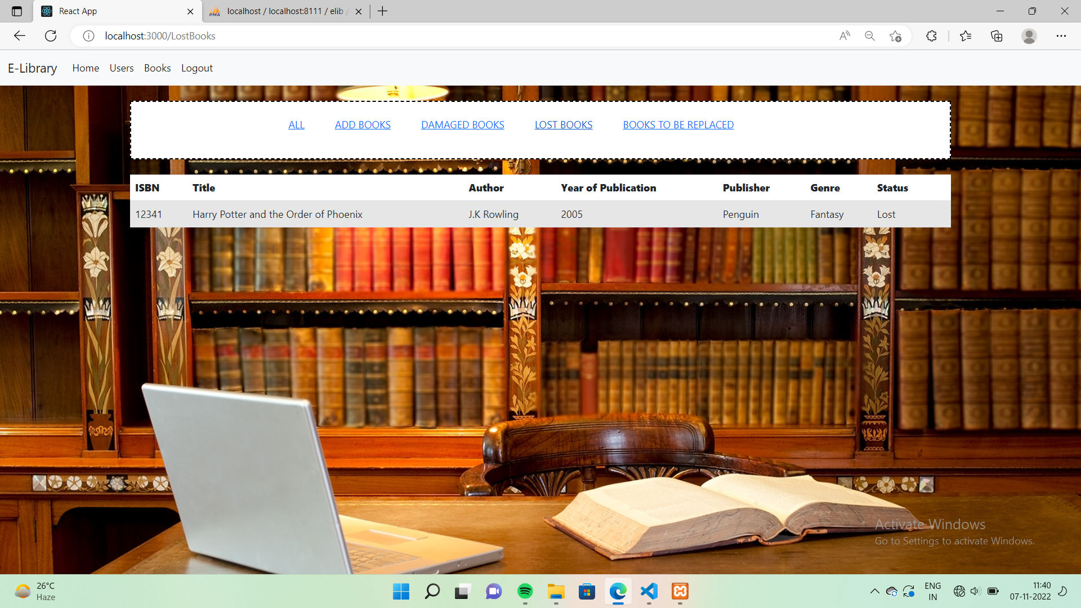

DISPLAYING ALL THE BOOKS THAT ARE DAMAGED:

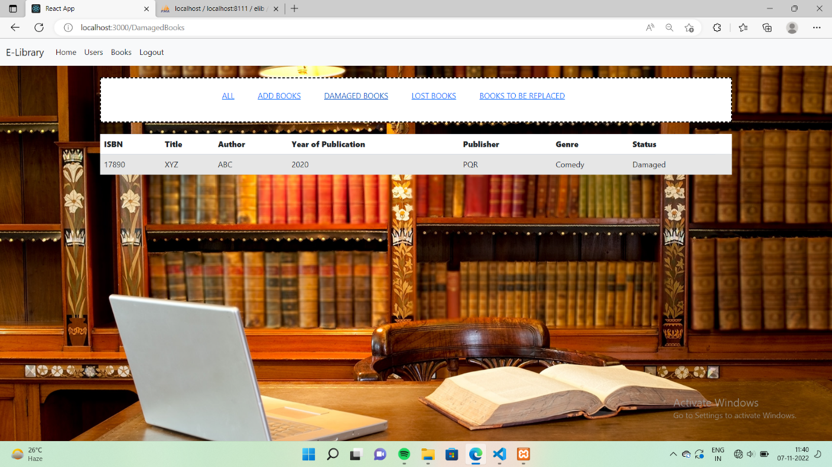

STATUS TABLE:

